Charter Document
Campus Events Application – MITAOE

Purpose
- To create a centralized platform for all MITAOE student clubs and departments to announce and manage their events.
- Allows students to browse, register, and get notified about upcoming events in one place.
- Supports event creation, updates, and filtering by category, club, or date.
- Enhances student engagement, simplifies event management, and promotes a digital campus experience.

Objective
To streamline the event management and registration process for MITAOE by:
- Providing a unified portal for all clubs to post upcoming events
- Allowing students to discover and register for club events or large-scale college events.
- Supporting category-wise filtering (e.g., cultural, sports, tech)
- Sending notifications and reminders
- Tracking user registrations and participation history
- Offering a user-friendly interface

Demand / Opportunity
Institutional Demand
Currently, event announcements in MITAOE are decentralized (e.g., posters, social media, WhatsApp groups). There is a strong need for a unified platform where:
- Clubs can manage and promote their events
- Students can easily view and register for events
- College admins can track engagement and participation
This project supports digital transformation and streamlines event operations campus-wide.

Business Requirement:
- User Authentication: Secure login/registration using email/password.
- Event Management (CRUD): Organizers can create, read, update, and delete events.
- Categorization & Tagging: Events are organized under categories and searchable tags.
- Event Registration: Users can register for an event and receive confirmation.
- Real-Time Notifications: Users get notifications when registered for the event.
- Search & Filters: Efficient search and filter options past, registered, upcoming events.
- Responsive Interface: Fully functional and optimized UI for all device types.

Technical Requirement

● User Authentication
○ UI for secure email/password login and registration
○ API routes for student and club admin sign-up, login, logout, and session management
○ Passwords securely hashed and stored in the backend using encryption techniques .
○ Session-based authentication system for protected routes and role management (Student, Club Admin)

● Event Management (CRUD)
○ API endpoints to create, read, update, and delete events by authorized club admins
○ Event fields include title, description, date, time, venue, category, poster.
○ UI for club admins to manage their event listings through a dashboard
○ Validation for event details before submission

●Event Registration System
○ UI for students to register for any event with a single click
○ Backend logic to track registered users for each event
○ Email confirmation using crons sent to students after successful registration
○ Dashboard to view upcoming and past registered events

● Search and Filtering
○ Backend logic for searching events by upcoming, past, registered events.
○ Frontend filters to allow users to refine events by category, club, or registration status
○ Sorting options based on upcoming date or popularity

● Real-Time Notifications
○ Notifications display on email after registering for an event.

● Data Storage
○ Secure and scalable SQL database for storing user profiles, event details, registration lists, and favourites.
○ Collection design to handle different user roles, event categories, and Nakshatra data.

Technological Requirement
🖥️Frontend
- React.js – For building an interactive, component-based user interface.
- Tailwind CSS – For a modern, responsive, and easily customizable design system.
🛠️ Backend
- Node.js + Express.js – For creating RESTful APIs that handle user authentication, event creation, registrations, and more.
- Nodemailer + CRON Jobs – Used to schedule and automatically send:
  - Event registration confirmation emails
  - Club communications and reminders
- Forget Password Feature – Implemented using Crypto for secure token generation and Nodemailer with Gmail SMTP for sending reset password emails.
🗄️ Database
- SQL – A relational database used to store:
  - User information
  - Event and club details
  - Registration history
  - Authentication tokens (e.g., password reset)
☁️ Hosting & Deployment
- Vercel – For deploying and hosting the frontend application.
- Render – For deploying and hosting the backend server and APIs.
🧪 Development & Testing Tools
- Visual Studio Code – Main code editor used for development.
- GIT & GitHub – For version control and team collaboration.
- Postman – To test REST APIs and validate request/response cycles.
- SQL GUI Tools (e.g., phpMyAdmin, TablePlus) – For visualizing and managing the SQL database manually.

Stakeholder:

Role | Name(s) | Count
Developers | Aditi, Shravani, Sayali | 3
DB Designer | Sayali | 1
Testers | Pooja, Janhavi, Shravani P, Jayesh Raut | 3
Project Management | Aditi | 1
Documentation | Shravani (Creator), Sayali (Reviewer) | 2
Hosting Provider | Render, Vercel | 1
Event Admins | All MITAOE clubs | -
Students (Users) | All MITAOE students | -

Resources Needed:
🔧 Development Stack
- React.js – For building the frontend user interface.
- Tailwind CSS – For responsive and customizable UI design.
- Express.js – For creating backend REST APIs and handling server-side logic.
- MongoDB – For storing user data, event details, and registration records.
- Nodemailer – For sending:
- Event registration confirmation emails
- Password reset emails using Gmail SMTP (with Crypto for secure token generation)
- Scheduled reminders using Node-Cron

🧪 Dev & Testing Tools
- Postman – For testing and validating API endpoints.
- Git & GitHub – For version control and seamless team collaboration.
- Visual Studio Code – Main code editor used for both frontend and backend development.

☁️ Hosting & Deployment
- Vercel – For deploying and hosting the frontend React application.
- Render – For deploying and hosting the backend Node.js/Express APIs.
- Human Resource

Role | Count | Name(s)
UI/UX Designer | 1 | Shravani Ingle
Frontend Developer | 2 | UI Development – Shravani, API Integration – Sayali
Backend Developer | 1 | Sayali
DB Designer | 1 | Shravani
Project Management | 1 | Aditi
Documentation | 2 | Creator – Shravani , Reviewer – Sayali Deshmukh
Tester | 2 | Pooja, Janhavi, Shravani P, Jayesh Raut

PESTEL Analysis:
- Political
- No direct government constraints for a college-level internal platform.
- Requires alignment with MITAOE’s institutional IT and data usage policies.

- Economic
- Utilizes a low-cost, open-source tech stack (React, Node.js, SQL) suitable for student projects.
- Affordable hosting via platforms like Vercel (frontend) and Render (backend) helps keep operational costs minimal.

- Social
- Encourages student engagement by centralizing event discovery and registration.
- Enhances the visibility and reach of club events and college fests like Nakshatra.

- Technological
- Built using scalable and well-supported technologies (React, Node.js, SQL).
- Mobile-responsive UI ensures accessibility across various devices.
- Uses CRON jobs with Nodemailer for scheduled email notifications.

- Environmental
- Promotes a paperless culture by digitizing event promotion and registration.

- Legal
- Must ensure secure storage of student data and protect user credentials.
- Requires user consent for receiving email notifications and follows basic data privacy practices.

Risk Analysis:

Risk | Description | Mitigation
Low Adoption | • Students may not know about the platform.  • They may continue using posters/WhatsApp. | • Promote via college campaigns.  • Introduce it during club orientations.
Data Misuse | • Organizers may access data from other clubs.  • Risk of unintentional data exposure. | • Implement role-based access.  • Restrict access per user role.
Feature Overload | • Too many features can confuse users.  • MVP may get delayed or buggy. | • Focus on essential features first.  • Plan extras for later versions.
Server Overload | • App may lag or crash during large events.  • Increased simultaneous usage can cause downtime. | • Use pagination & caching.  • Optimize backend queries.
Security Vulnerabilities | • Risk of unauthorized admin access.  • Sensitive data could be compromised. | • Use session and input validation. • Maintain secure logs and headers.

Timeline / Milestone:

Phase | Tasks (Detailed) | Timeline
Requirement & Planning | • Identify all stakeholders (students, club admins).  • Gather feature requirements (event posting, registration, filtering, etc.).  • Create user flow diagrams and design wireframes for key screens (event list, event creation, registration, dashboard). | Week 1
Backend Development | • Set up Express.js project structure.  • Develop RESTful APIs for event CRUD, user registration/login, and student-event registration.  • Implement session-based authentication and role-based access (student, club admin).  • Integrate Node mailer with cron jobs for confirmation emails. | Week 2
DB & API Design | • Design database schema for users, events, registrations.  • Establish entity relationships (e.g., user ↔ event, club ↔ event).  • Define API endpoints for user auth, event management, and registration workflows. | Week 3–4
Frontend Development | • Build UI components using React.js and Tailwind CSS (event list, registration form, admin dashboard, event creation/editing form).  • Add filtering, search, and category selection features. | Week 5–6
Integration & Testing | • Connect frontend with backend APIs using Axios/fetch.  • Test complete workflows: event creation, registration.  • Perform unit testing and manual testing across different roles and scenarios.  • Fix bugs and improve UX. | Week 7
Final Deployment | • Deploy the frontend on Vercel.  • Deploy backend on Render.  • Configure environment variables (API keys, DB connection).  • Conduct live testing and final review before presentation/submission. | Week 8

RACI Chart:
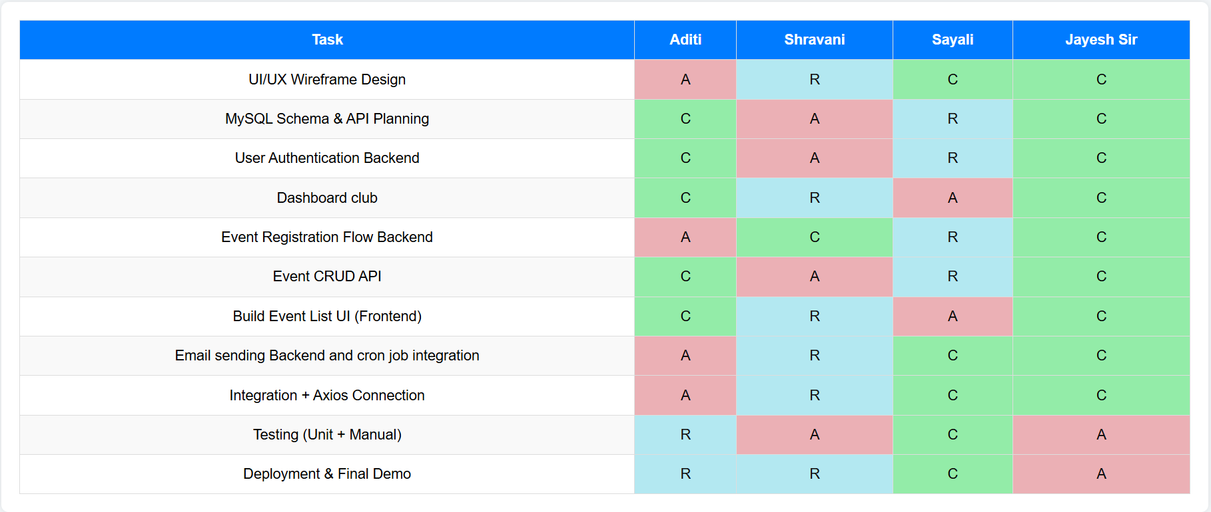

- R = Responsible (executes the task)
- A = Accountable (owns the outcome)
- C = Consulted (input provider)

